**Exercise - Create and run a simple flow**

In this exercise, you'll create a flow that copies a selected folder and then adds information about the created backup in a Microsoft Excel file.

To create the flow:

1. Launch Power Automate for desktop and then select the **New flow** button in the console.

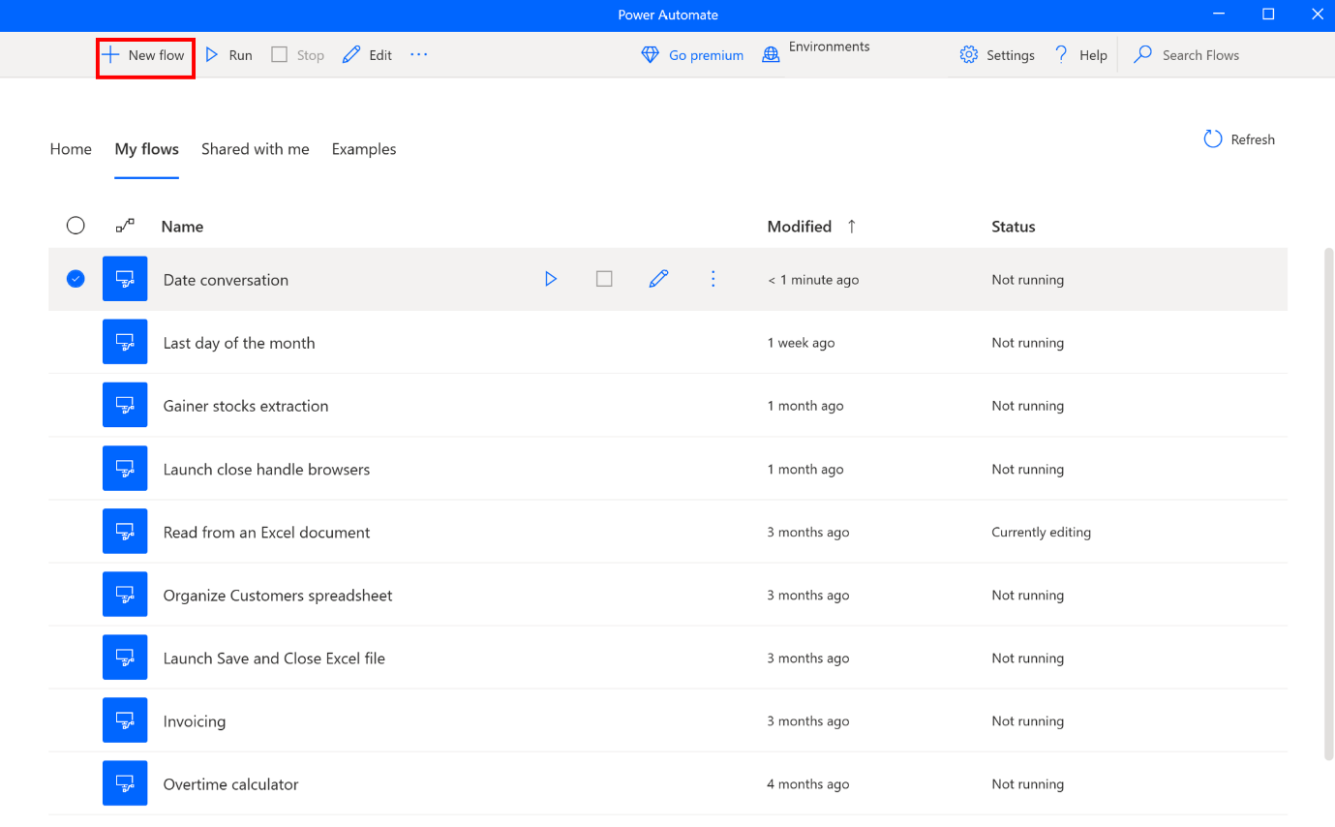

1. Choose a name for your flow and then select the **Create** button. For this example, the flow is named **Backup flow**.
2. When the flow designer is launched, add a **Display select folder dialog** action to prompt users to select a folder.

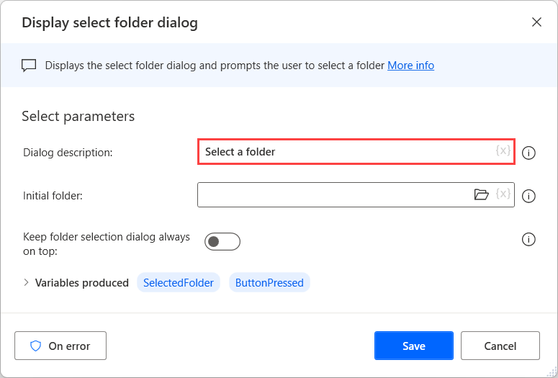

1. Use a **Copy folder** action to copy the selected folder in your documents folder.

**Important**

Make sure the destination folder already exists so that the flow can copy the files.

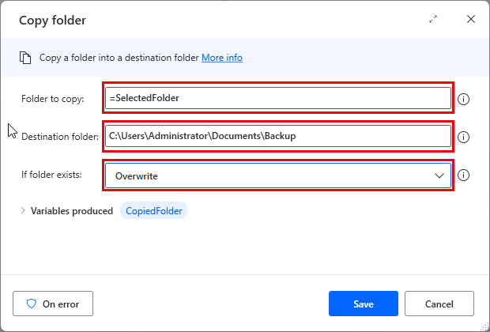

1. Deploy a **Launch Excel** action to open the Excel file that contains the logs about your backup activity.
   1. If this file doesn't already exist, create a blank Excel spreadsheet named **Logs.xlsx** in the **Desktop** folder so that the automation will be able to open it as an existing file.

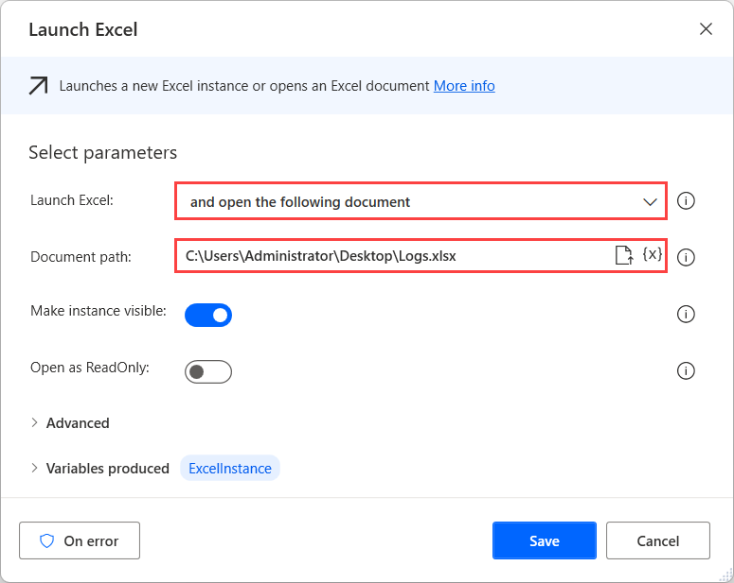

1. To find the first available row in the Excel file, use the **Get first free column/row from Excel worksheet** action.

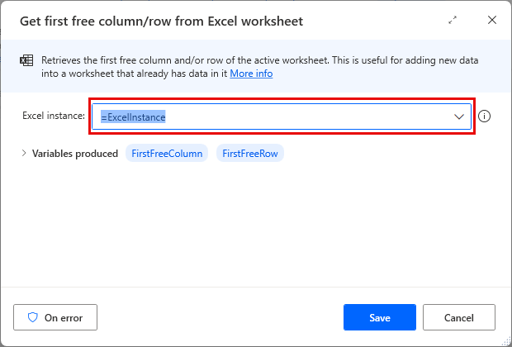

1. To get a timestamp of the current time for the logs, use the **Get current date and time** action.

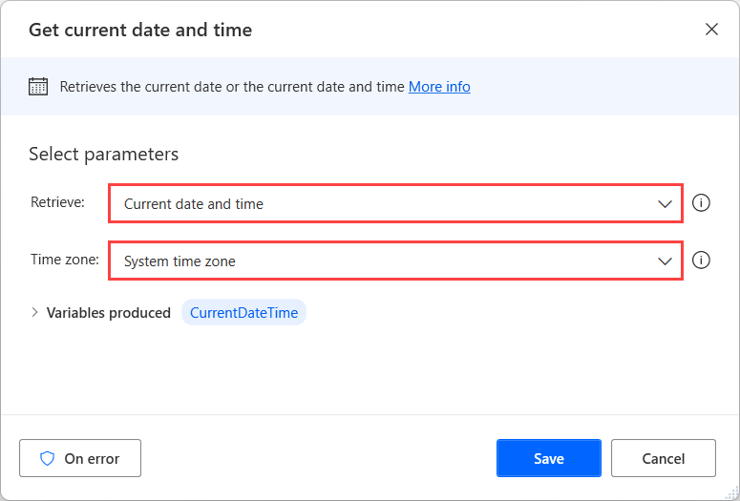

1. Deploy two **Write to Excel worksheet** actions to add log information in the Excel file.
   1. Use the first **Write to Excel worksheet** action to write the copied folder's path in the first column of the first available row.

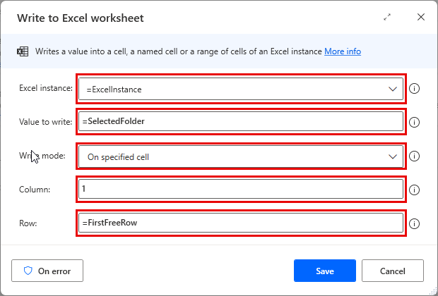

* 1. Use the second deployed action to add a timestamp in the second column of the first available row.

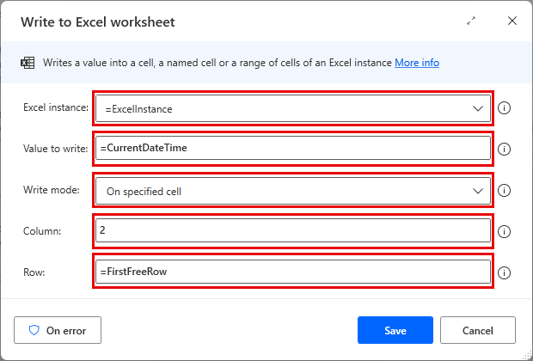

1. Use a **Close Excel** action to save and close the Excel file.

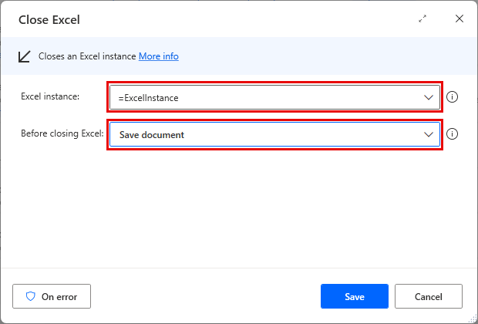

1. To test that the flow runs as expected, select the **Run** button, pick a folder, and then check that the log file has been updated.

[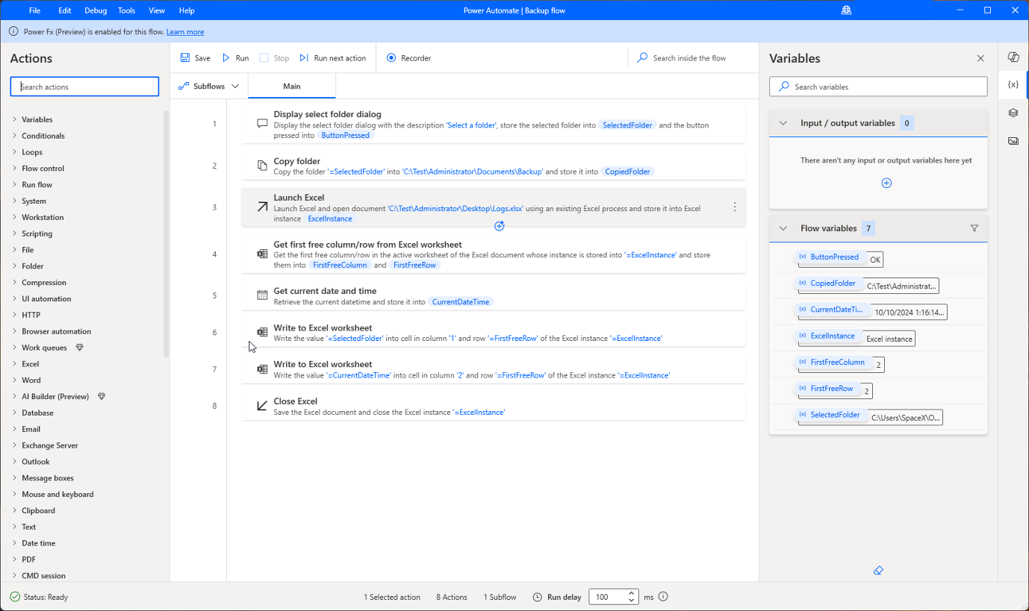](https://learn.microsoft.com/en-us/training/modules/pad-first-steps/media/exercise-6.png#lightbox)

1. If the flow works as expected, save it and then close the flow designer.